Precision Vices & Sine Tables

HARDENED AND GROUND PRECISION GRINDING VICE Screw Type

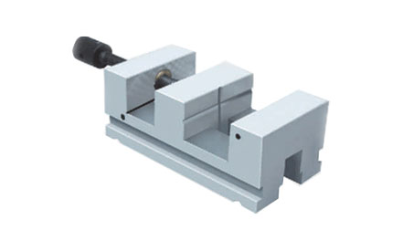

Used for holding the jobs, right angle grinding & Light machining.
Made from high quality alloy steel.
Accuracy for Squareness, Flatness & Parallelism within 0.005mm.
Hardness 60 ± 2 Rc & Tempered.
Wear Plate at bottom to prevent lifting of Jaw
Hardened clamping screw with square thread & gun metal nut
Tenon at bottom to allow easy alignment with machine bed

Sr.No. | Cat.No | Size (mm) | Jaw Height (mm) | Opening (mm) | Step in Jaw (mm)
1. | UL - 31101 | 150L x 45W x 45 H | 22 | 0 - 70 | 3x2
2. | UL - 31102 | 175L x 60W x 44 H | 28 | 0 - 80 | 3x3
3. | UL - 31103 | 190L x 75W x 65 H | 32 | 0 - 85 | 4x3
4. | UL - 31104 | 210L x 95W x 75 H | 38 | 0 - 95 | 5x3

SINE-TABLE IS : 5939-1970

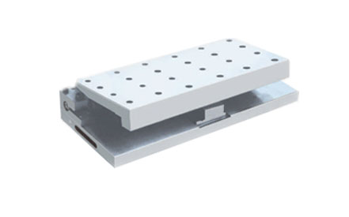

Used for Precision measurement, setting of angles
utilizing slip gauge & light machining.
Accuracy for squareness, Parallelism & flatness is
0.005mm upto 200L & 0.010mm upto 450L.
Angle can be set within ±5 seconds.
Centre Distance between rollers is within 0.005mm.
Made from high quality alloy steel
Hardness - 60 ± 2 Rc & Tempered.
Firm hinged clamp to reduce possibility of distortion.
M6 & M8 tapped holes for job clamping.

SR.No. | Cat No. | Size (mm) | Center Distance | Inclination
1. | UL - 40101 | 150 L x 120 W x 65 H | 70 | 0 - 45º
2. | UL - 40102 | 250 L x 150 W x 65 H | 100 | 0 - 45º
3 | UL - 40103 | 300 L x 150 W x 65 H | 100 | 0 - 45º
4. | UL - 40104 | 450 L x 150 W x 65 H | 100 | 0 - 45º

COMPOUND SINE-TABLE IS: 5939- 1970

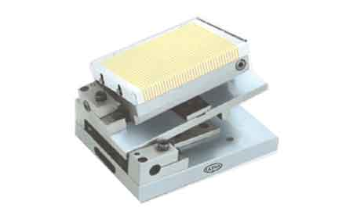
Used for Precision measurement, setting of angles & Light machining.
Accuracy for Square ness, Flatness & Parallelism
within 0.005mm upto 200L & 0.010mm upto 450L.
Angle can be set within ±5 seconds.
Centre Distance between rollers is within 0.005mm.
Made from high quality alloy steel
Compound Angle facility.
Hardness - 60 ± 2 Rc & Tempered.
Magnetic Table for job holding.
Firm hinged clamp to reduce possibility of distortion.

Sr. No | Cat No. | Size (mm) | Bottom C.D (mm) | Top C.D (mm)
1. | UL - 40401 | 150 L x100 W x 155 H | 100 | 50
2. | UL - 40402 | 250 L x150 W x 155 H | 150 | 100
3. | UL - 40403 | 300 L x150 W x 155 H | 200 | 100
4. | UL - 40404 | 450 L x150 W x 155 H | 300 | 100
5. | UL - 40405 | 400 L x200 W x 155 H | 250 | 150

COMPOUND SINE-TABLE IS : 5939 - 1970

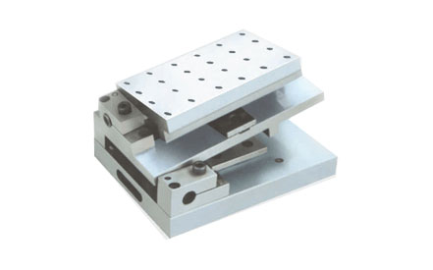

Used for Precision measurement, setting of angles & Light machining.
Accuracy for Square ness, Flatness & Parallelism
within 0.005mm upto 200L & 0.010mm upto 450L.
Angle can be set within ±5 seconds.
Centre Distance between rollers is within 0.005mm.
Made from high quality alloy steel.
Compound Angle facility.
Hardness - 60 ± 2 Rc & Tempered.
Firm hinged clamp to reduce possibility of distortion.
M6 & M8 tapped holes for job clamping.

Sr.No. | Cat No. | Size (mm) | Bottom C.D | Top C.D
1. | UL- 40201 | 150 L x 100 W x 95 H | 100 mm | 50 mm
2. | UL- 40202 | 250 L x 150 W x 95 H | 150 mm | 100 mm
3. | UL- 40203 | 300 L x 150 W x 95 H | 200 mm | 100 mm
4. | UL- 40204 | 450 L x 150 W x 105 H | 300 mm | 100 mm

MAGNETIC SINE-TABLE IS : 5939- 1970

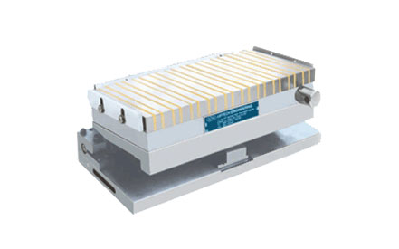

Used for Precision measurement, setting of angles & Light machining.
Accuracy for Square ness, Flatness & Parallelism
within 0.005mm upto 200L & 0.010mm upto 450L.
Angle can be set within ±5 seconds.
Centre Distance between roller is within 0.005mm.
Made from high quality alloy steel
Hardness - 60 ± 2 Rc & Tempered.
Magnetic Table for job holding.
Firm hinged clamp to reduce possibility of distortion.

Sr.No | Cat.No | Size (mm) | Center Distance | Inclination
1. | UL- 40301 | 150 L x 120 W x 105 H | 70 mm | 0 - 45º
2. | UL- 40302 | 250 L x 150 W x 105 H | 100 mm | 0 - 45º
3. | UL- 40303 | 300 L x 150 W x 105 H | 100 mm | 0 - 45º
4. | UL- 40304 | 450 L x 150 W x 105 H | 100 mm | 0 - 45º
5. | UL- 40305 | 500 L x 200 W x 105 H | 150 mm | 0 - 45º

